# TITLE OF THE PAPER

Author Name1, Author Name2 and Author Name3 (Full Names, No Abbreviation)

1Faculty, University, Country; 2,3 Company, Country

## Abstract

Please read all the information given in this Template carefully before starting to type. The paper must contain at least 8 Figures and/or Tables. Please use Times New Roman 10 Font size. The paper title must be between 50 to 100 characters in length. The abstract must contain a "Problem statement, Approach, Results, and Conclusions." The size of the abstract must be between 150 ~ 250 words. Please use this document as a template. The paper length should be 4 to 6 pages long. Any page or fraction thereof exceeding 6 pages will be charged extra fees. The additional author fee is needed if exceeding 5 authors. If the paper is NOT according to this Template – it will NOT be published in the proceedings. The author must pay to register for the inclusion of the conference paper in the proceedings. Please double-check that there are ten font sizes throughout the paper except for the title, which is 14 font sizes only. Do not write the author's email or position in the author's section above. Only use the name of the Department or Faculty, University, and Country.

*Keywords: Four or five keywords (The first characters of each keyword are in uppercase letters), Italic*

## INTRODUCTION

The paper size is 210mm×297mm of A4 paper. Please save it to the MS Word templates directory.Use 10-point Times New Roman font throughout the paper, including text inside figures and tables. Single-line spacing is mandatory. Try to avoid underlining or Bold within texts.

The top margin is 30mm, while the left, right, and bottom margins are 25 mm. Headings should be left justified and without a number. Leave one line between headings and the first paragraph and no space before succeeding paragraphs. Indent the first line of the paragraph by 5mm. All text should be left and right justified. Footnotes and underlines are not allowed.

## RESEARCH SIGNIFICANCE

The significance of the study is basically the importance of your research. The significance of your study must be stated in this section of your research paper. The size of the research significance should be between 70 to 100 words. It should identify the significance and potential impact of the reported work on the state of the art or practice.

## HEADINGS

Use at most three levels of headings that correspond to chapters, sections, and subsections. The first level headings for chapter titles should be in 10pt, bold, justified, and upper case font. Leave one blank line before and after the first level headings, respectively.

**The Second Level Headings**

The second-level headings should be in 10pt, bold, justified, and the First Characters of Each Word are in Capital font. Leave one blank line both before and after the heading, respectively

The third level headings

These headings should be in 10 pt, italics, and sentence case. Insert one blank line before the headers but no line space after the headers. Further lower-level titles should be avoided. Follow the style exactly of this Template.

## tables, figures AND EQUATIONS

Figures or Tables should be sized the whole width of a column, as shown in Table 1 or Fig.1 in the present example, or the entire width over two columns. Do not place any text besides the figures or tables. Please do not put them together at the end of the manuscript.

### Tables

Table numbers and labels should be placed on top of the table, hanging by 12.5 mm, and left- and right-justified (Table 1). Number the tables consecutively, locate them after, and close to where they are first referenced. Leave at least one line space between the table, label, and text. Tables should be auto-fit to a single column or the whole width over two columns, and no vertical lines or borders are needed. Font size in all tables must be 8-10 font sizes times new roman or similar. Footnotes should be 8 font size times new roman and italic. Too large or too small fonts are not allowed.

Table 1 This is an example of table formatting

|  |  |  |  |
| --- | --- | --- | --- |
| Items | x | y | z |
| a | 5 | 2 | 5 |
| b | 6 | 1 | 6 |
| c | 8 | 3 | 9 |
| d | 10 | 4 | 11 |
| e | 11 | 5 | 15 |
| f | 12 | 6 | 16 |
| g | 13 | 7 | 17 |
| h | 14 | 8 | 18 |

*Note: Should be placed under the table, leaving no space in-between; 8-10pt font, and left- and right-justified.*

### Figures

Figure numbers and labels should be placed one line under the figure, hanging by 12.5 mm, and left- and right-justified. Number figures consecutively in the order in which reference is first made to them in the text. Locate them after and close to where they are first referenced (Fig.1). Please do not compress the figure (images of 600 dpi resolution or more are preferable). Draw figures clearly and embed text in the image properly. Do not cut and paste from another text and ensure the pictures look useful and readable after printing.

Figures should be auto-fit to a single column or the whole width over two columns. Font size in all figures must be 10 font sizes times new roman or similar (Not too big and not too small) (Fig. 1). Do not use outer borders, italics and bold (Figs. 2-5). One good example and 4 bad examples have been given for your reference. Please follow all the instructions strictly.

You may use color figures and photographs in your paper. These will appear in color on the online version of the journal. However, please check that your color figures are legible when printed in monochrome (black and white), as this is how they will be reproduced in the hardcopy version of the journal.

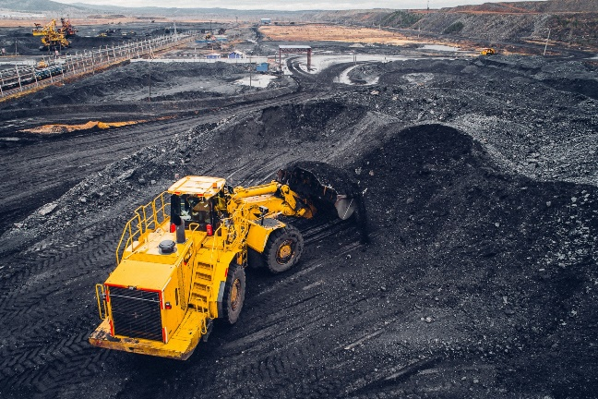

Fig.1 This is a good example of figure formatting

**Equations**

Equations and symbols should be typed in the equation editor. Number equations consecutively with equation numbers in parentheses, as in

 (1)

Refer to "Eq. (1)" not "equation (1)," except at the beginning of a sentence: like "Equation (1) is ... ."

The equation number, enclosed in parentheses, is placed right justified. Symbols and notation should be defined when they first appear. Use one blank line before and after the equation.　Equations should be auto-fit to a single column or the whole width over two columns.

**CITATION AND REFERENCE LIST**

Number citations consecutively in square brackets [1]. The sentence punctuation follows the frames [2]. Multiple references [2,3] are each numbered within one frame [1-3]. When citing a section in a book, please give the relevant page numbers. In sentences, refer simply to the reference number, as in [3]. Do not use "Ref. [3]" or "reference [3]" except at the beginning of a sentence: "Hossain [3] shows ... ."

Try to avoid footnotes. Give all authors' names; do not use "*et al*." Use a space after authors' initials. Papers submitted for publication or that have not been accepted or published should not be cited. Documents that are accepted for publication (but not yet specified for an issue) can be cited as "In press"[5]. The references are 5mm hanging indentations.

CONCLUSIONS

## Acknowledgments

## referenceS

The APA referencing style should be provided

[1] Husinsyah, H., Mahyudi, F., & Hasiani, Y. (2023). Study of Social Return of Investment (SROI) and Reclamation of CSR Program of Coal Mining Company in South Kalimantan Province Indonesia. International Journal of Science, Technology & Management, 4(3), 544-552.